Lab Tasks

Task 01:

#include <stdio.h>

main()

{

char character;

printf("Enter a character: ");

scanf("%c", &character);

switch (character) {

case 'a':

case 'A':

case 'e':

case 'E':

case 'i':

case 'I':

case 'o':

case 'O':

case 'u':

case 'U':

printf("Vowel");

break;

default:

printf("Not a vowel");

}

}

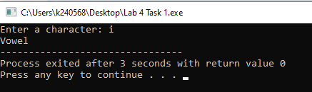

Task 02:

#include <stdio.h>

main()

{

float temperature;

printf("Enter temperature: ");

scanf("%f", &temperature);

if (temperature<10) {

printf("Cold"); }

else if (temperature >= 10 && temperature <= 25) {

printf("Mild"); }

else {

printf("Hot"); }

}

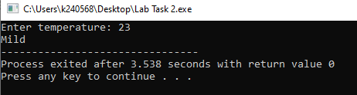

Task 03:

#include <stdio.h>

main()

{

float gpa;

char eca;

printf("Enter GPA: ");

scanf("%f", &gpa);

printf("Enter 'Y' if you have ECAs, 'N' for no ECAs: ");

scanf("\n%c", &eca);

if (gpa >= 3.5 && eca == 'Y')

printf("You are eligible for scholarship!");

else

printf("You are not eligible for scholarship");

}

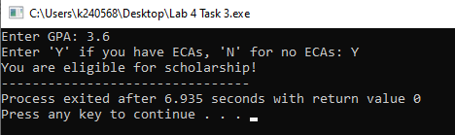

Task 04:

#include <stdio.h>

main()

{

int Num1;

int Num2;

printf("Enter First Number: ");

scanf("%d", &Num1);

printf("Enter First Number: ");

scanf("%d", &Num1);

if (Num1 == Num2) {

printf("The numbers are equal"); }

else if (Num1 > Num2) {

printf("First Number is greater"); }

else {

printf("Second Number is greater"); }

}

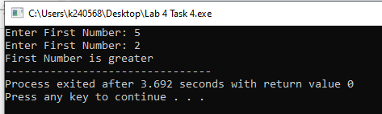

Task 05:

#include <stdio.h>

main()

{

char VehicleType;

int model;

printf("Enter 'C' for Car, 'M' for Motorcycle: ");

scanf("%c", &VehicleType);

printf("Enter Model Number: ");

scanf("%d", &model);

switch (VehicleType) {

case 'C':

switch (model) {

case 1:

printf("Model 1: Sedan, 1500cc, 4-door");

break;

case 2:

printf("Model 2: Hatchback, 1300cc, 5-door");

break;

case 3:

printf("Model 3: SUV, 2000cc, 4-door");

break;

default:

printf("Enter a valid model number");

}

break;

case 'M':

switch (model) {

case 1:

printf("Model 1: Cruiser, 250cc");

break;

case 2:

printf("Model 2: Sports, 600cc");

break;

case 3:

printf("Model 3: Dirt Bike, 450cc");

break;

default:

printf("Enter a valid model number");

}

default:

printf("Enter a valid Vehicle Type");

}

}

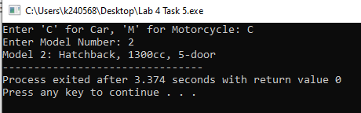

Task 06:

#include <stdio.h>

main()

{

float weight;

float height;

float bmi;

printf("Enter Weight: ");

scanf("%f", &weight);

printf("Enter Height: ");

scanf("%f", &height);

bmi = weight * 703 / height / height;

if (bmi < 15) {

printf("Your BMI lies in the category of Starvation"); }

else if (bmi < 17.5) {

printf("Your BMI lies in the category of Anorexic"); }

else if (bmi < 18.5) {

printf("Your BMI lies in the category of Underweight"); }

else if (bmi >= 18.5 && bmi < 25) {

printf("Your BMI lies in the category of Ideal"); }

else if (bmi >= 25 && bmi < 30) {

printf("Your BMI lies in the category of Overweight"); }

else if (bmi >= 30 && bmi < 40) {

printf("Your BMI lies in the category of Obese"); }

else if (bmi >= 40) {

printf("Your BMI lies in the category of Morbidly Obese"); }

}

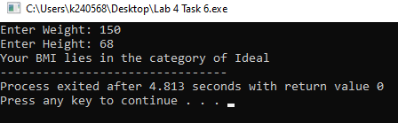

Task 07:

#include <stdio.h>

main()

{

char ShippingMethod;

printf("Enter\n 'E' for Express Shipping \n 'S' for Standard Shipping \n 'O' for Overnight Shipping \n 'R' for Regular Shipping: ");

scanf("%c", &ShippingMethod);

switch (ShippingMethod) {

case 'E':

printf("Rs. 200");

break;

case 'S':

printf("Rs.100");

break;

case 'O':

printf("Rs. 300");

break;

case 'R':

printf("Rs. 50");

break;

default:

printf("Invalid shipping method");

}

}

